TITLE OF SUBMISSION
Author's Name(s)¹, Author's Name(s)², Author's Name(s)³
¹Author Affiliation(s), ²Author Affiliation(s), ³Author Affiliation(s),
COUNTRY.
¹E-mail(s), ²E-mail(s)
ABSTRACT
The abstract is to be in fully-justified italicized text, at the top of column as it is here, below the author information. Use the word “Abstract” as the title, in 12-point Times, boldface type, centered relative to the column, capitalized. The abstract is to be in 11-point, single-spaced type, and up to 250-300 words in length.
Keywords: APA, Qualitative, Quantitative, Research, Academia [4-5 key words or phrases should be included.]

INTRODUCTION
These guidelines include complete descriptions of the fonts, spacing, and related information for producing your proceedings manuscripts. Please follow guidelines and email your paper to editor.arint@journals.savap.org.pk
The articles need to be not published elsewhere previously. If the article has been presented at any seminar or conference, the name of the conference, the institution where it has been presented and the date of the presentation needs to be mentioned. The Journal is written in English. Thus, the articles need to be written in this language.
The title of the article must be written in capital letters, using font size 14 and bold. One line space must be left after the title. The name and surname of the author(s), their title, and the institution they work for and its email or web site must be written font size 11 in upper or lower case as mentioned.
The number of the pages of the article must not exceed 20, including abstract and reference list. The whole work must be written in Times New Roman, font size 12. Subheading must be in bold, and the first letter of each word should be in capital letters.

HEADING 1 – MAIN HEADING LEVEL

Heading 2 – Subheading

Heading 3 – Subheading

Heading 4 – Subheading
All the text must be written using single line spacing, including the reference list. The article should normally consist of the following parts: introduction, context and review of literature, method, findings, discussion and conclusion.
All inserts, figures, diagrams, photographs and tables must be centre-aligned, clear and appropriate for black/white, gray scale or colored reproduction.
In tables font size 11 must be used and vertical lines must be not be drawn. When the contents of the table cannot fit into the table, font size 10 might be used. Number of the table and the title should be written above the table. Tables (eg, Table 1) are also numbered consecutively, 1, 2, etc., from start to finish of the paper, ignoring sections and subsections, and independently from figures.
Table 1. Xxxxx xx xxxxx xxxxxx
 | Xxxx | Xxxx | Xxxx
Xxxx Sxxx | xxx | xxx | xx.x %
Xxxx Sxxx | xxx | xxx | xx.x %
Xxxx Sxxx | xxx | xxx | xx.x %
Xxxx Sxxx | xxx | xxx | xx.x %
The items on the reference list must be arranged according to APA Referencing. (Publication Manual of the American Psychological Association). Go to http://owl.english.purdue.edu/ owl/resource/560/01 for more information.
Figures (eg, Figure 1) must be numbered consecutively, 1, 2, etc., from start to finish of the paper, ignoring sections and subsections.
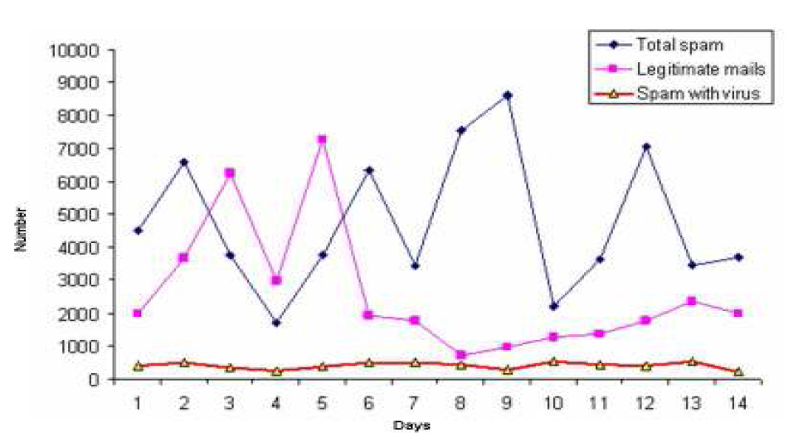
Figure 1. Xxxx xxxx xxxx xxx xxxxxx
All figures, tables, etc. must have a caption, centre-justified in 11 pt. Times New Roman. Captions precede tables but follow figures. Tables and figures should appear as close to their point of reference as satisfactory formatting of the final document permits.
In-Text citations
Use the name of the author(s) followed by the year of publication when citing references within the text and page number. For example:
1 authors (Callan, 1998), 2 authors (Eggen and Kauchak, 2001), 3 or more authors (Levine et al., 2002)
ACKNOWLEDGEMENTS
An (unnumbered) acknowledgements section may be inserted if required.

REFERENCES
List and number all bibliographical references in 12-point Times, single-spaced, at the end of your paper in APA style. All in-text references must be included in list of references.
How to create a reference list?
Single author:
- Feldman, R. S. (1996). Understanding Psychology. Newyork: McGraw-Hill,Inc.
- Calapkulu, C. (2011). The Framework of “Uses and Gratıfıcatıons Approach” the Televısıon Vıewıng Purpose of Chıldren in the 3-6 Age Group. Academic Research International,1(1), 20-42.
2 authors:
- Eggen, P. & Kauchak, D. (2001). Educational Psychology: Windows on Classrooms. New Jersey: Merrill.
- Erden, M. & Akman, Y. (1996). Egitim Psikolojisi (Educational Psychology). Ankara: Arkadas Yayınevi.
3 or more authors:
- Levine et al., (2002). Signal Analysis of Behavioral and Molecular Cycles. BMC Neuroscience, 3: 1-25.

